**PUT THE TITLE OF THE PAPER HERE, AND USE ALL CAPS FOR EACH WORD**



**AUTHORS NAME HERE 1[1]*, AUTHOR NAME HERE 2 , AUTHOR NAME HERE 3**

1*Put author’s affiliation here, complete with address, postal code, and country*

2*Put author’s affiliation here, complete with address, postal code, and country*

3*Put author’s affiliation here, complete with address, postal code, and country*

|  |  |
| --- | --- |
| ARTICLE INFORMATION  *SUBMISSION HISTORY:*  Received: 3 January 2024  Revised: 3 March 2024  Accepted: 5 May 2024  Published: 31 June 2024  *KEYWORDS:*  Alphabetically Sorted;  Capitalize Each Word; Maximum 5 keywords;  Keyword 4;  Keyword 5 | ABSTRACT  An abstract with no more than 300 words and a 9pt font size should be supplied to reflect the paper’s content. An abstract should serve as a succinct summary of a research paper, encapsulating its critical elements while ensuring readability and coherence when presented independently from the main text. It should begin with a brief introduction to the research’s background, offering insight into the problem’s context and highlighting its significance in the relevant field. This is followed by a clear statement of the research’s objectives or aims, laying the foundation for understanding the study’s purpose and its intended contributions. The methodology section should succinctly describe the principal methods employed in the research, including the study design, data collection techniques, and analytical approaches, without delving into excessive detail. Following this, the abstract should concisely present the study’s key results, focusing on the most significant findings and their implications. Finally, the abstract should conclude with a statement on the major contributions of the research, summarizing its significance and the value it adds to the existing body of knowledge. This could include new insights, theoretical advancements, or practical applications derived from the study’s findings. Throughout the abstract, it’s crucial to avoid the use of references or citations, as well as non-standard or uncommon abbreviations. If such abbreviations are indispensable, they must be defined upon their first appearance within the abstract itself. |

**1. INTRODUCTION**

Introduce the research topic and its context. Highlight the importance and relevance of the problem being addressed. Clearly define the problem your research addresses. This should be specific and directly related to the field of study. State the main objectives or goals of your research. What does the study aim to achieve or discover? If applicable, list the research questions or hypotheses. Explain why this problem is important and worthy of investigation. Provide a brief overview of the structure of the paper. Mention what each section will cover without going into too much detail.

**2. BACKGROUND OR LITERATURE REVIEW**

Provide an adequate background context of the problems based on the literature review. State the objectives of the work and emphasize the originality (state-of-the-art). Clearly identify what is missing in the current body of literature. This could be unexplored areas, limitations of existing studies, or conflicting findings. Explain how these gaps limit our understanding or application of the research topic.

**3. METHODS**

Describe how the study was carried out in sufficient detail to allow replication. Justify the choice of methods and explain how they were used to address the research questions or hypotheses. Detail the procedures for data collection, including the tools, techniques, and materials used. Describe the experimental setup for experimental research, including control and experimental groups, variables measured, and how interventions were implemented. Specify any software, programming languages, or tools used in the study, including versions and configurations. If custom software was developed, provide a brief description and, if possible, a reference to where the code can be accessed. Describe the statistical or computational methods used to analyze the data. If applicable, describe any steps taken to ensure data accuracy and reliability. Mention any ethical approvals obtained for the study, especially involving human participants. Describe steps taken to protect participants’ privacy and data security. You can involve all this information using a suitable structure such as in the following:

**3.1 Data Collection**

**3.2 Data Analysis**

**3.1.1 Data Pre-Processing**

**3.1.2 Features Extraction**

**4. Results**

Objectively present the findings of the study. Provide a clear and logical sequence of the results related to the research questions or hypotheses. Present the results logically, typically following the arrangement of the study’s research questions, hypotheses, or experiments. Use tables, figures, graphs, and text to present the data. Ensure each table or figure is clearly labeled and mentioned in the text. Provide statistical analysis results, including measures of central tendency, variability, and statistical significance tests. Clearly state the statistical software or tools used. Highlight significant findings, including unexpected results, while refraining from discussing their implications. Ensure that the presentation of results is concise and focused on the most relevant data.

**5. Discussion**

**6. Conclusion**

**7. Acknowledgement**

**8. Conflict of Interest**

If there is no conflict of interest, then the authors should state that: The authors declare that there is *no conflict of interest* regarding the publication of this paper.

Or if there are conflicts, then the authors might state that:

The first author is a consultant for [Company Name], which may stand to benefit from the results of this study. The second author has received research funding from [Organization Name]. All potential conflicts have been managed in accordance with [Institution’s Name] policies.”

# Formatting Guidelines

Font: Cambria, Font Size: 10-point font for the main text, Line Spacing: Single-spacing, Paragraphs: Indent the first line of each paragraph by 1.5 cm (using the Tab key), Margins:(Top 3cm, Left 3cm, Bottom 2.5cm, Right 2.5cm, Headings: If your introduction includes subsections (which is less common), use **Bold** for headings and ensure they are aligned left. After each heading, leaf 5pt line spacing

**Heading Numbering Guidelines**

**Title:** not numbered, centered, Font: Cambria, Size: 16 **Bold**, ALL CAPS.

**Author Names:** centered, Font: Cambria, Size: 10 **Bold**, ALL CAPS.

**Abstract** and Keywords (not numbered): Justified, Font: Cambria, Size: 11.

**Main Body Sections**: Start numbering from the introduction. The numbering format typically follows a hierarchical structure, such as:

**Font and Style**

Use the first-level headings for the section headings (Bold, All Caps, Size 10). For sub-sections, maintain the same font size and bold, and Capitalize Each Word (e.g., **3.1 Data Collection**). Use these settings for the Sub-sections beyond the second level (e.g., **3.1.2 Features Extraction**).

**Alignment**

All headings should be aligned to the left.

**Spacing**

Include a space after the heading number and before the text. Leave a blank line before each heading to separate it from the preceding text or section.

**Tables**

Tables are a fundamental element in academic writing, used to organize and present data clearly and concisely. Proper arrangement and captioning of tables are crucial for readability and to effectively communicate your findings. Place the caption above the table. The caption should include a table number (e.g., Table 1, Table 2) followed by a clear and concise title describing the table’s content and context. The title should be informative enough that readers understand what the table is about without needing to refer to the text in the document. Table Captions should be left aligned with 10pt font size, and only the word Table# should be bolded.

**Table 1**: Performance Comparison of Machine Learning Algorithms

|  |  |  |  |  |
| --- | --- | --- | --- | --- |
| Algorithm | Accuracy (%) | Precision (%) | Recall (%) | F1 Score (%) |
| Decision Tree | 89.5 | 90.2 | 88.8 | 89.5 |
| Random Forest | 92.3 | 91.7 | 93.2 | 92.4 |
| SVM | 88.7 | 89.0 | 88.4 | 88.7 |
| Neural Network | 94.2 | 94.5 | 93.9 | 94.2 |
| k-NN | 87.4 | 87.9 | 86.8 | 87.3 |

**Figures**

Figures are also fundamental in academic writing, used to organize and present data clearly and concisely. Proper arrangement and captioning of figures are crucial for readability and effective communication of your findings. Place the caption under the figure. The caption should include a figure number (e.g., Figure 1, Figure 2) followed by a clear and concise title describing the figure’s content and context. The title should be informative enough for readers to understand its contents. Figures Captions should be left aligned with 10pt font size, and only the word Figure# should be bolded. Use the word (Fig #) inside the paragraphs when referring to any figure.

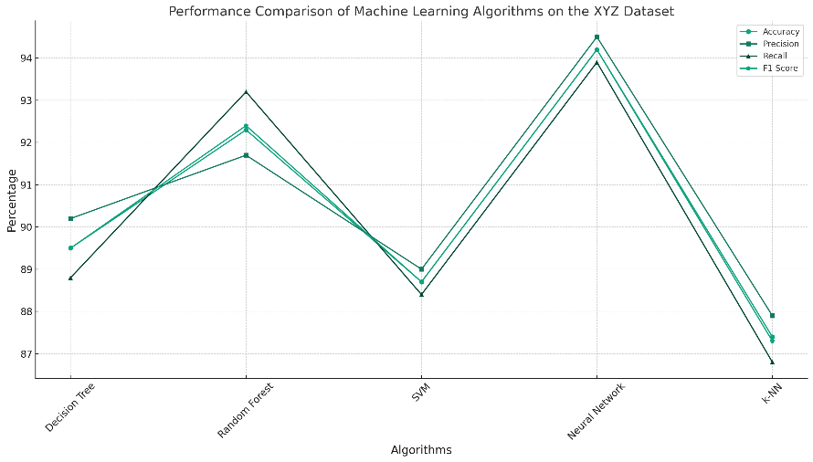

**Figure 1**: A comparison of the performance metrics accuracy of five ML algorithms.

**Equations**

Incorporating and describing equations in a research paper is essential for presenting mathematical models, theories, or relationships central to your study. Each equation should be numbered sequentially throughout the text. The number is typically placed in parentheses and aligned on the right side of the page or column. Place the equation on a new line, ensuring it’s clearly visible and separate from the text. This enhances readability and helps readers focus on the equation itself. When referring to an equation in the text, use “Equation (1)” instead of just “equation” or “(1),” providing a clear reference for readers.

${\left(x+a\right)}^{n}=\sum_{k=0}^{n}{\left({n \atop k}\right)x^{k}a^{n-k}}$… (1)

**Algorithms**

Describing and presenting algorithms in a research paper involves providing a clear, step-by-step explanation of how the algorithm works, often accompanied by pseudocode. Pseudocode is a simplified, language-neutral description of the steps in the algorithm, formatted to resemble coding structure without being executable code. Choose the format that best suits the complexity and nature of the algorithm.

**Algorithm 1**: Binary Search Pseudocode

1. BinarySearch(Array A, Value v):

2. Start = 0

3. End = length(A) - 1

4. WHILE Start <= End:

5. Mid = (Start + End) / 2

6. IF A[Mid] == v:

7. RETURN Mid

8. ELSE IF A[Mid] < v:

9. Start = Mid + 1

10. ELSE:

11. End = Mid - 1

12. RETURN -1

**References**

Use IEEE style for your references and citations. In the IEEE citation style, references are numbered, appearing in square brackets in the text, and listed in the order they are cited in the “References” section at the end of your paper. Here’s how to handle different types of references in IEEE style:

**Books** **Format**

[#] Author’s Initials. Author’s Last Name, Title of the Book in Italics, xth ed. City of Publisher, Country (if not commonly known): Publisher, year, pp. xx-xx.

**Books Reference:**

[1] J. Doe, The Art of Data Science, 2nd ed. New York, NY: Springer, 2018, pp. 45-50.

**Journal Articles Format:**

[#] Author’s Initials. Author’s Last Name, “Title,” Journal in Italics, vol. xx, no. xx, pp. xx-xx, Month year.

**Journal Articles Example:**

[2] A. B. Smith and C. D. Johnson, “New approaches to machine learning,” IEEE Transactions on Pattern Analysis and Machine Intelligence, vol. 40, no. 6, pp. 1350-1362, June 2019.

**Conference Papers Format:**

[#] Author’s Initials. Author’s Last Name, “Title of paper,” in Title of Published Proceeding: Proceedings of the Title of Conference, City of Conference, Country, year, pp. xx-xx.

**Conference Papers Example:**

[3] L. M. Wong, “Improving deep learning,” in Proc. International Conference on Artificial Intelligence, Los Angeles, CA, USA, 2020, pp. 204-210.

**Theses and Dissertations Format:**

[#] Author’s Initials. Author’s Last Name, “Title of thesis,” M.S. thesis or Ph.D. dissertation, Dept., University, City of University, State, year.

**Theses and Dissertations Example:**

[4] E. F. Taylor, “Quantum computing algorithms,” Ph.D. dissertation, Dept. of Comp. Sci., Massachusetts Institute of Technology, Cambridge, MA, 2021.

**Websites Format:**

[#] Author’s Initials. Author’s Last Name (if available), “Title of the page,” Name of the Website in Italics. Available: URL. Accessed on: Month Day, Year.

**Example:**

[5] Epoch, “Machine Learning Trends,” Data Science Today. Available: https://epochai.org/data/epochdb. Accessed on: April. 4, 2024.

**Electronic Sources (e.g., Databases, Online Journals) Format:**

[#] Author’s Initials. Author’s Last Name, “Title of article,” Title of Journal/Source in Italics, volume, page numbers, year. [Online]. Available: URL

**Electronic Sources Example:**

[6] S. Zhang and A. Lee, “Deep learning for image recognition: advances and challenges,” International Journal of Advanced Computer Science, vol. 35, no. 2, pp. 256-264, 2023. [Online]. Available: http://www.ijacsjournal.com/deep-learning-image-recognition-2023

**Maximum of the paper length: 13 pages**

1. * Corresponding author, E-mail addresses: author@mail.com (Author Name)